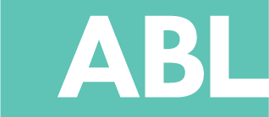

ABL SUMMIT SCHOLARSHIP APPLICATION

Please fill out the form below and return to ablacademy@kidsfit.com. You will receive an email with a quoted amount that reflects the amount of scholarship funds you have been awarded in order to attend the ABL Summit of your choice.
Full Name
Title/Specialty
County
District
School Name and Address
Target Grade Level
Title 1 School?
ABL Experience?
Do you currently utilize ABL labs or furniture? If so, how you are practicing ABL?
Approx Budget you would like to apply for
Overall, what percentage of your school currently practices active learning?
How will attending this training benefit you and your staff?

Which areas would you like to see improved? Check All that Apply  (If desired, you may number them in order of priority 1-12. Highest Priority = 1 Lowest  Priority = 12) | ___Attendance  ___Academic Achievement  ___Parent/Community Involvement  ___Behavior  - Bullying  - Students are not engaged in learning/Distracted  - Acting out in Class  ___Special Needs Program  ___Low-Income Students  ___Physical Education Program  ___Getting teachers on board  ___Getting the administration on board  ___ Large Class Sizes, Hard to effectively teach every student  ___Obesity, poor student health  ___Funding

